delaware Student Game



Assignment Case Student Game

Group number:

1 Deliverables 3

2 “How might we?” (HWM) 4

3 Deliverables Strategy definition 5

3.1.1 Summary of the strategy for the new request 5

3.1.2 Vision on costs, environment, customer satisfaction, lead times, etc. 6

3.1.3 How about brand awareness? Company image? 6

4 Deliverables implementation of the solution BIG IDEA 7

4.1.1 Solution title *Name of your genius idea? In 1 sentence* 7

4.1.2 Theme *Which theme are you working on?* 7

4.1.3 How might we question *Which part of the customer’s problem are you working on?* 7

4.1.4 Target *Who are you helping with your solution?* 7

4.1.5 Select the Technologies, applications and reasoning behind the solution that you want to elaborate for the business case 7

4.1.6 Solution *What is your solution to the customer’s problem?* 7

4.1.7 Insights process 7

4.1.8 Identify possible risks and define scenarios to prevent and solve possible issues that relate to your solution 7

4.1.9 Evaluation of the solution: KPI’s…(SMART?) 8

5 Lean Canvas 9

5.1.1 Problem 9

5.1.2 Segments 9

5.1.3 Solution 10

5.1.4 Unique value proposition 10

5.1.5 Channels 10

5.1.6 Most important activities 10

5.1.7 Partners & Stakeholders 10

5.1.8 Most important resources & technical feasibility 10

5.1.9 Cost structure 10

5.1.10 Revenue 10

6 User Journey Map 12

6.1.1 Actors 13

6.1.2 Goals 13

6.1.3 Discovery 13

6.1.4 Learning 13

6.1.5 Use 13

# Deliverables

For the elaboration and preparation on the technical aspect in the system, the case should be thought out functionally. Based on the information from the customer presentation and also based on the interaction Q&A with the customer of the case the case needs to be elaborated. Below a strategy plan and functional elaboration will need to be elaborated. For every question, some space is foreseen below. This should not be perceived as a limitation or an obligation to use the specific question structure. Think out of the box.

This information can always be used in the functional part of the pitch.

Some useful tips:

* Be creative
* Don’t write a book
* Visualize!
* When using assumptions, state and justify them

# “How might we?” (HMW) (functional + technical)

“How might we” (HMW) questions are short questions to start your brainstorm.

1. Break down your customer’s problem into (2-3) smaller problems.
2. How do their customers experience the problem?
3. How will you:
   * **Improve** the customer’s **good** practices?
   * **Replace** the customer’s **bad** practices?
   * **Discover** what can be done completely **differently**?
   * **Find** **unexpected** resources and be prepared for unexpectedchallenges?

# Deliverables Strategy definition

### Summary of the strategy for the new request

*An analysis about the use of the new technology*

#### Where and Why (drivers)?

Which solutions we can use.

#### Strategy for the new request: How?

Which strategy we can use for our solution.

#### SWOT analysis (Strength, Weaknesses, Opportunities and Threats)

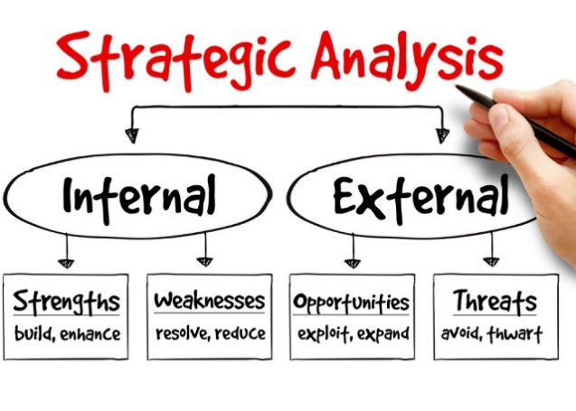

#### Position in the market (competition,…)

Where do we position ourselves in the market.

Example:   
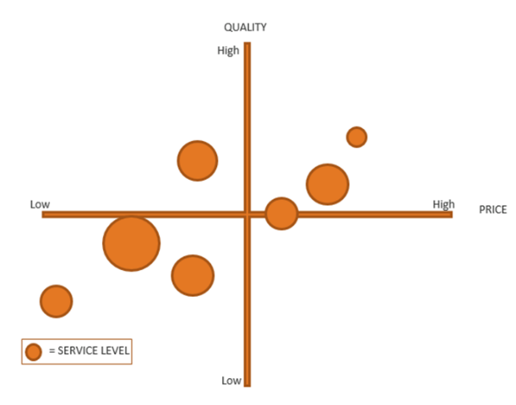

### Vision on costs, environment, customer satisfaction, lead times, etc.

### How about brand awareness? Company image?

# Deliverables implementation of the solution BIG IDEA

Following deliverables are expected:

### Solution title *Name of your genius idea? In 1 sentence*

### Theme *Which theme are you working on?*

### How might we question *Which part of the customer’s problem are you working on?*

### Target *Who are you helping with your solution? What are their expectations?*

### Select the Technologies, applications and reasoning behind the solution that you want to elaborate for the business case

### Solution *What is your solution to the customer’s problem?*

### Process flow

Align the functional flow with the technical solution.

### Identify possible risks and define scenarios to prevent and solve possible issues that relate to your solution

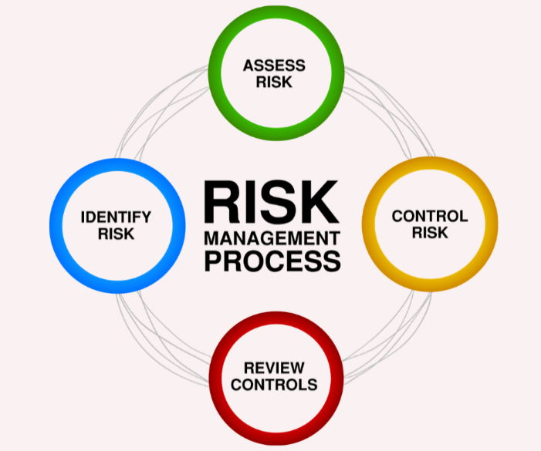

### Evaluation of the solution: KPI’s…(SMART?)

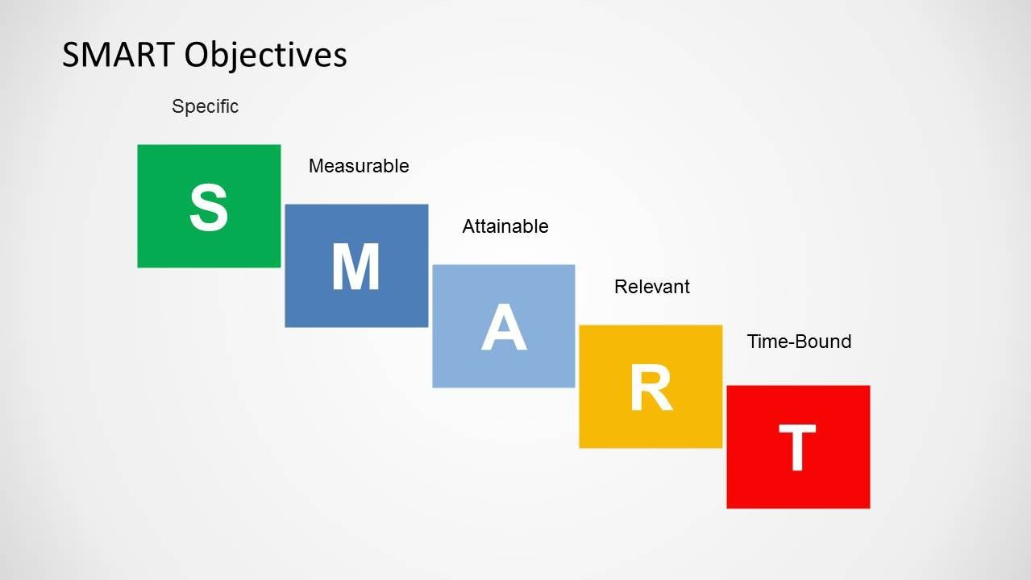

# Set up your solution in the system (technical)

Now it’s time to get your hands dirty & set up your solution.

# Lean Canvas

Inspired by the Business Model Canvas, Lean Canvas and Social Business Model Canvas

**This Lean Canvas will help you prepare for the pitch to our senior management. This is a great tool to see if your solution will be a success or failure. How much do you know about your solution? Fill in every block and try to list what you know and don’t know about your solution. Use sticky notes to update your canvas every time you learn something more about each block.**

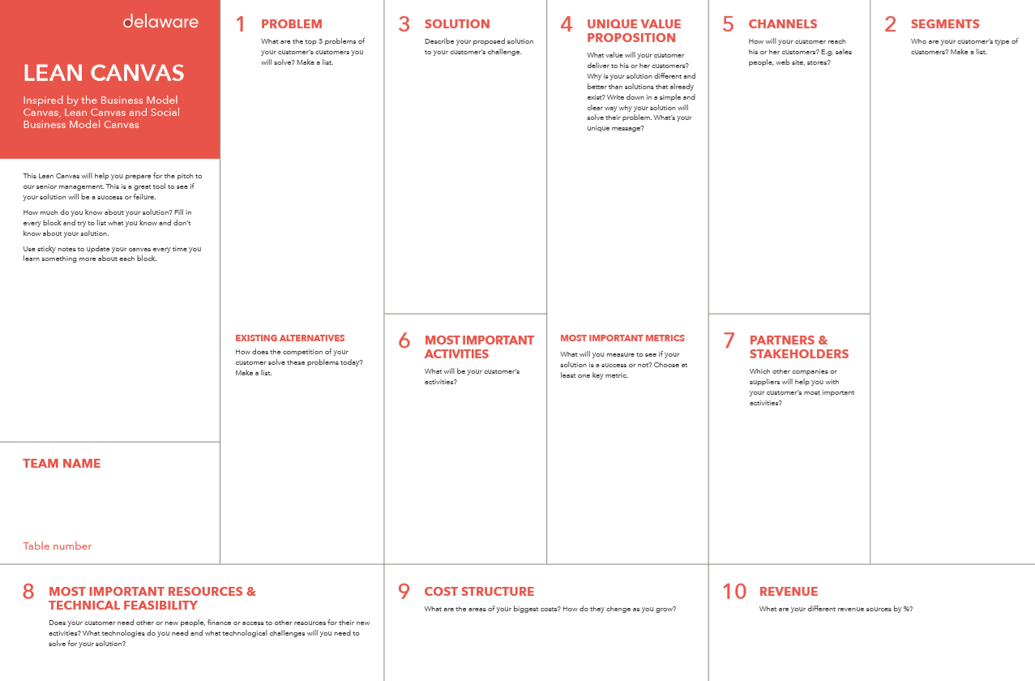

### Problem

*What are the top 3 problems of your customer’s customers you will solve? Make a list.*

### Segments

*Who are your customer’s type of customers? Make a list.*

### Solution

*Describe your proposed solution to your customer’s challenge.*

**We will dl**

### Unique value proposition

*What value will your customer deliver to his or her customers? Why is your solution different and better than solutions that already exist? Write down in a simple and clear way why your solution will solve their problem. What’s your unique message?*

#### Most important metric

*What will you measure to see if your solution is a success or not? Choose at least one key metric.*

### Channels

*How will your customer reach his or her customers? E.g. sales people, web site, stores?*

### Most important activities

*What will be your customer’s activities?*

### Partners & Stakeholders

*Which other companies or suppliers will help you with your customer’s most important activities?*

### Most important resources & technical feasibility

*Does your customer need other or new people, finance or access to other resources for their new activities? What technologies do you need and what technological challenges will you need to solve for your solution?*

### Cost structure

*What are the areas of your biggest costs? How do they change as you grow?*

### Revenue

*What are your different revenue sources by %?*

# User Journey Map

This tool helps you decide what you should prototype and test with users and experts

**HOW TO?**

**1. Make a list of the 3 most important personas (max): you will focus on them first.**

(Personas represent your customer’s customers or stakeholders).

**2. Make a list of the goals for those personas after they interact with your solution.**

**3. Map the journeys by listing the key touchpoints:**

• When do customers of your customer first discover your solution? Online, through devices, through human services, through partners, etc... ?

• When do they learn more about your solution and

• When are they actually using it?

**4. Now ask yourself: who is the most important persona and what is the most important moment of interaction with your solution? Circle that touchpoint. It is this interaction that you should prototype and test with users, stakeholders and experts.**

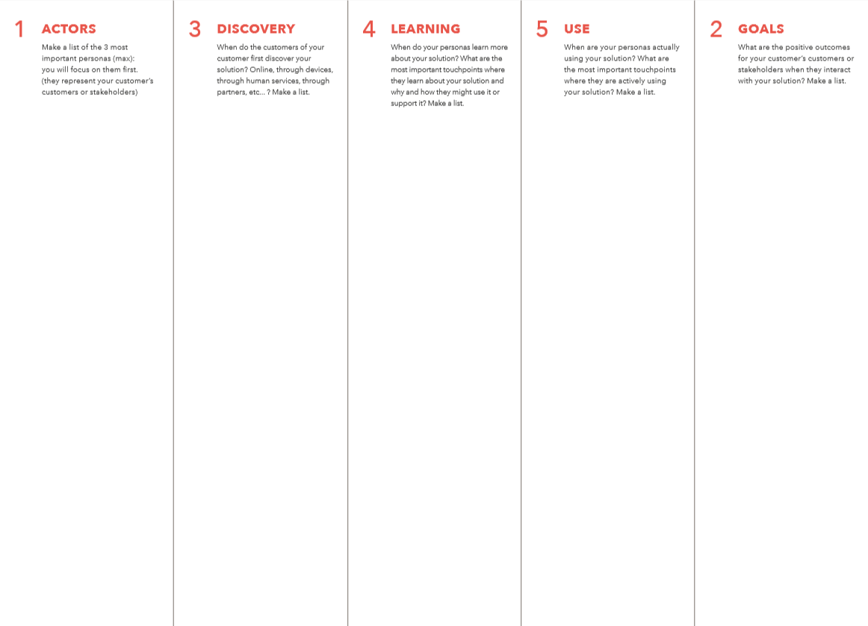

### Actors

*Make a list of the 3 most important personas (max): you will focus on them first. (they represent your customer’s customers or stakeholders)*

### Goals

*What are the positive outcomes for your customer’s customers or stakeholders when they interact with your solution? Make a list*

### Discovery

*When do the customers of your customer first discover your solution? Online, through devices, through human services, through partners, etc... ? Make a list*

### Learning

*When do your personas learn more about your solution? What are the most important touchpoints where they learn about your solution and why and how they might use it or support it? Make a list.*

### Use

*When are your personas actually using your solution? What are the most important touchpoints where they are actively using your solution? Make a list.*